**Coursera – Applied Data Science with Capstone**

**Clustering London Tube Stations using 4Square**

**Background**

Tourism is a vital part of the UK economy, accounting for 9.6% of jobs (<https://www.visitbritain.org/visitor-economy-facts>). In particular, London represents 55% of the tourism market, hosting a record 19.8m visits in 2017 (<https://www.visitbritain.org/nation-region-county-data>). With each visitor spending on average £683, it is important to both tourists and local businesses that trips are planned efficiently in order to explore as much as possible of the capital city.

Due to high congestion levels, one of the most convenient methods of transport in London is the underground network. This report will cluster stations in zones 1 and 2 to help tourists and businesses plan the best route around the city.

**Data**

This project will utilise a number of tools and sources, namely:

* Jupyter Notebook for carrying out analysis
* 4Square API for extracting venues nearby underground stations.
* Doogal (<https://www.doogal.co.uk/london_stations.php>) which provides a list of all London Underground stations as a CSV file.

**Methodology**

Lat/Long values for each station was read in from Doogal as a CSV and tidied to include only zone 1 and 2. These were then fed to 4Square API using a venues get request to get all venues within a 200m distance from the station. These were then grouped for each station and the venue type was ranked based on frequency. The stations were then clustered using a simple k-means method with 5 clusters and the results were plotted on a Folium map.

**Results and Discussion**

Two maps were created through this project – one plotting all stations within zone 1 and 2 of the London Underground, and another showing clustered grouping from these stations.

Un-clustered plot of London Underground stations:

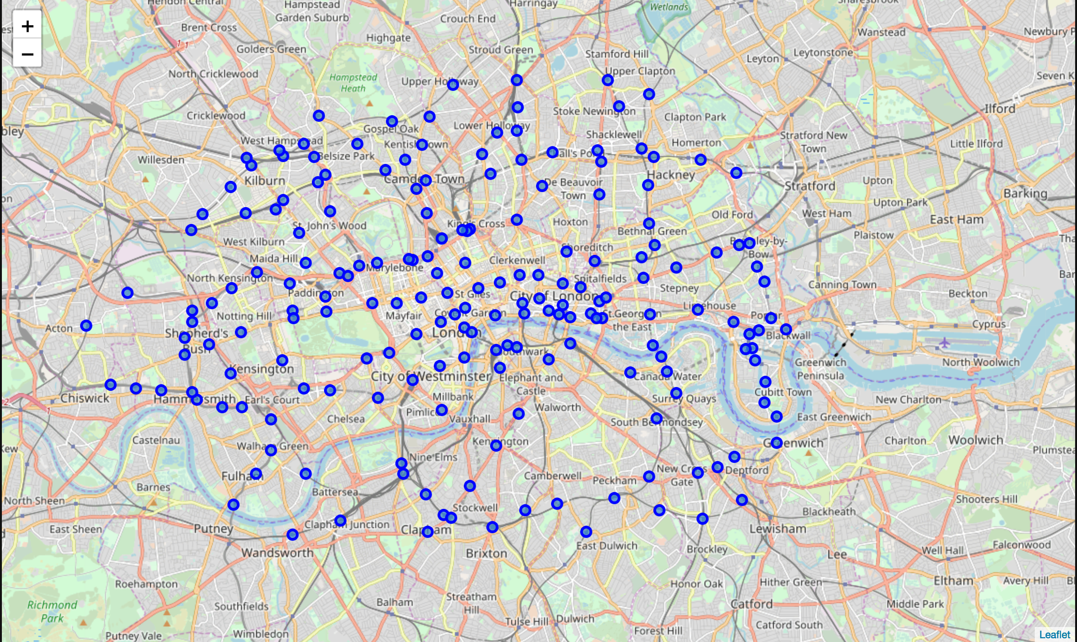

Clustering of Underground Stations:

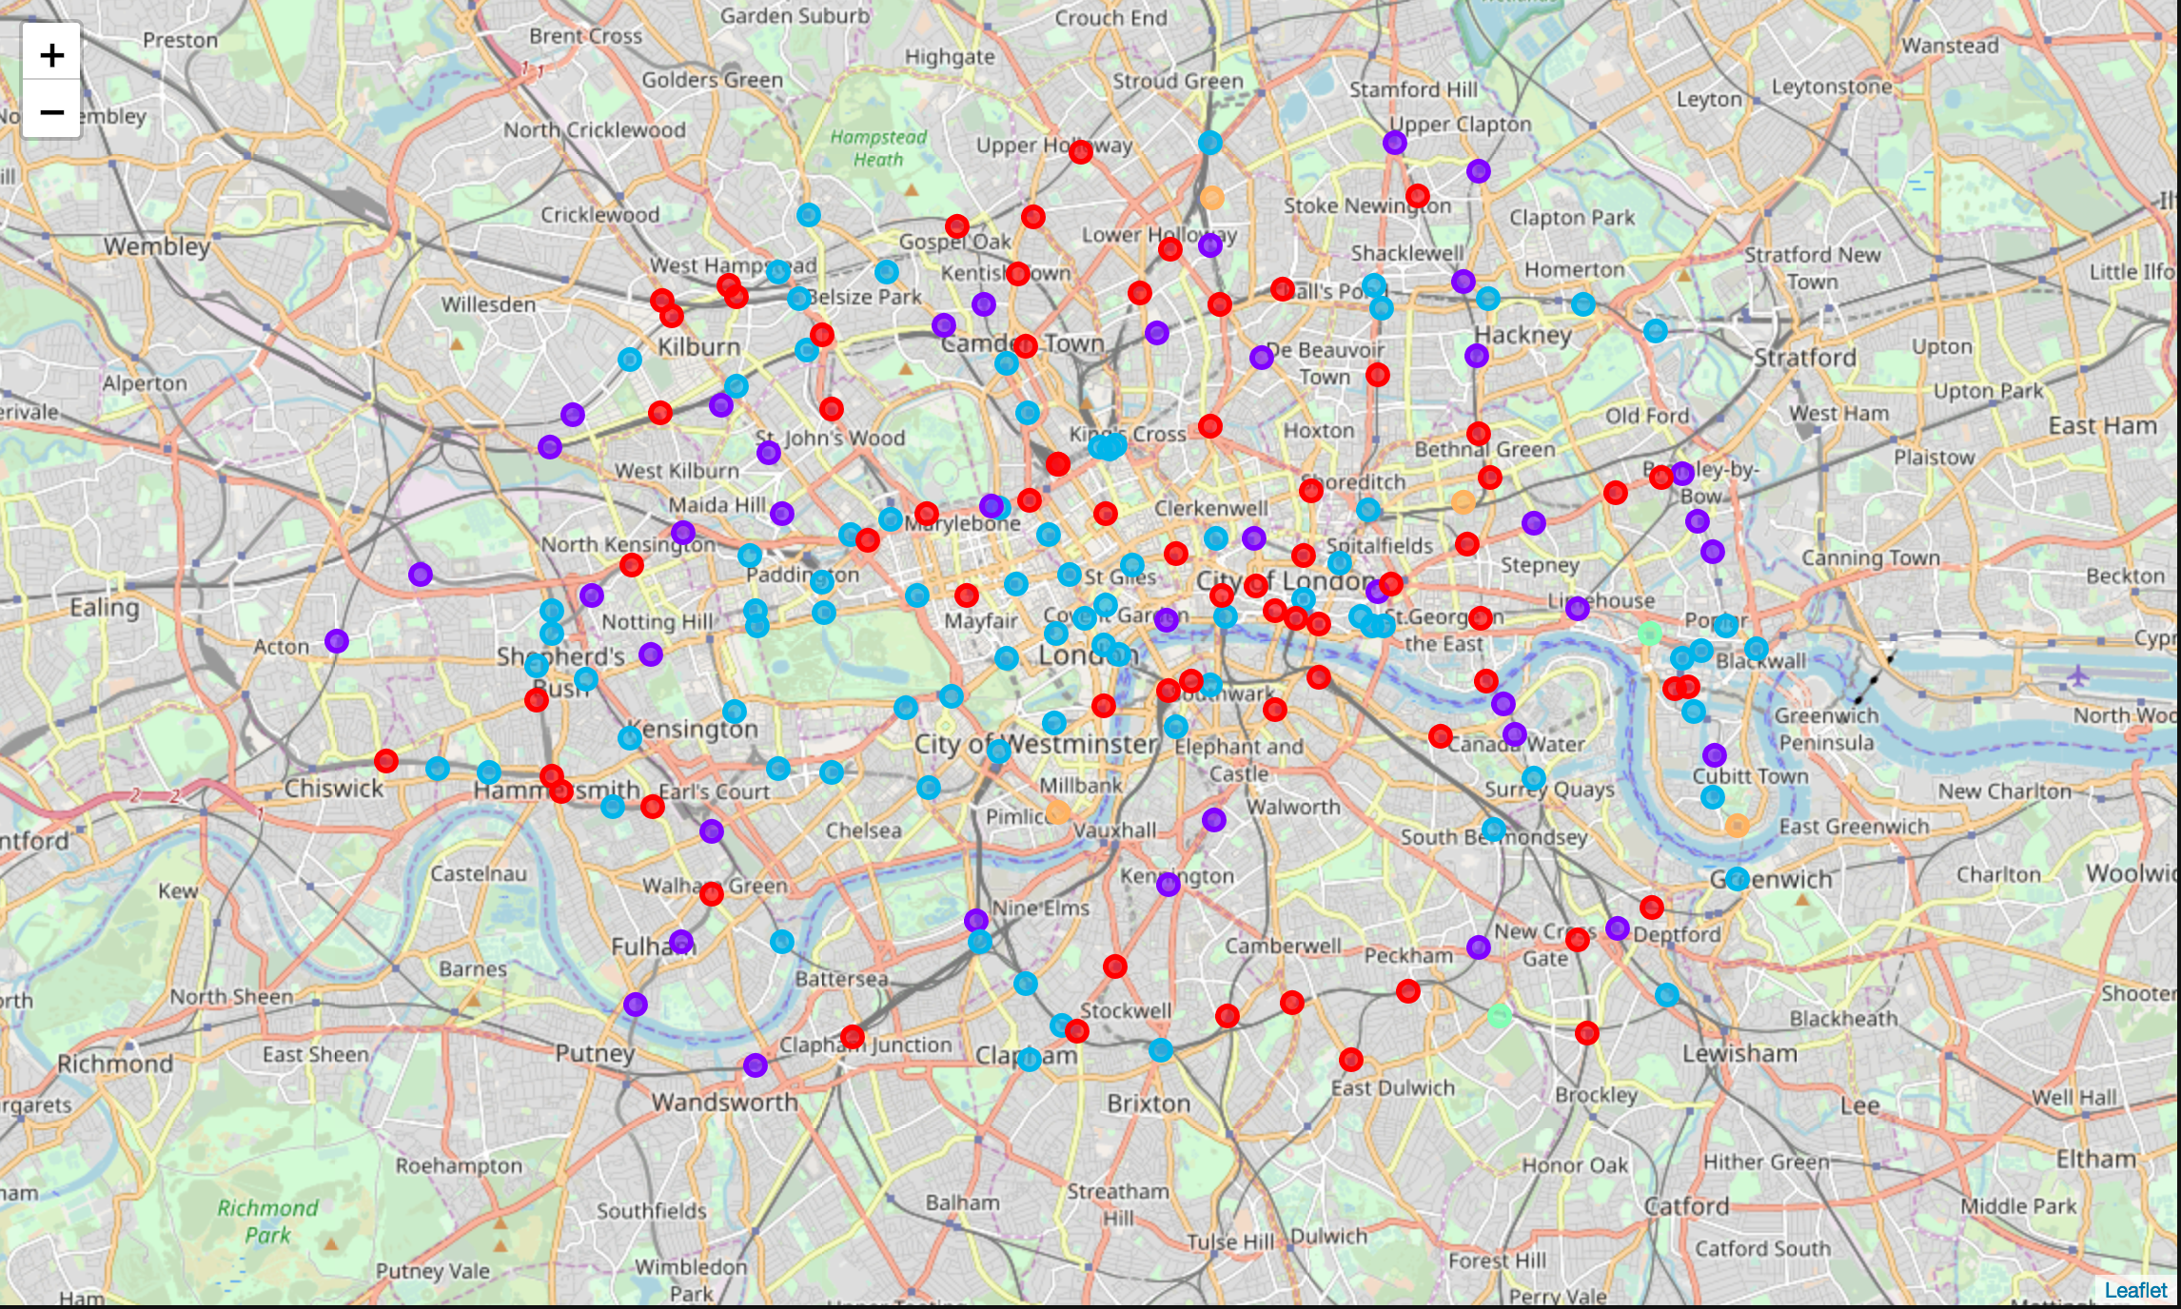

These clusters categorise the underground stations based on the nearest venues within 200m. A description for each cluster can be seen below:

Red Cluster – Predominantly coffee shops and pubs with some convenience stores

Purple Cluster – Mainly pubs most common with bars and hotels

Blue Cluster – Restaurants and hotels with some retail shops

Green Cluster – Market stalls with some restaurants

Orange Cluster – Parks and sports facilities

**Conclusion**

Through this project, it was found that underground stations can be grouped into distinctive clusters based on their nearby characteristics. This can then be used by tourists or businesses to plan the best route for travelling around London.